ADVERTISEMENT FOR BIDS

Sealed proposals for Single-Prime bids will be received until 2:00 pm on Tuesday, March 24, 2026 at the ASU Facilities Annex, 2458 Hwy. 105 S., Boone, NC 28608, in the Large Conference Room 119 for the construction of Appalachian State University, University Hall Fire Sprinkler System project at which time and place bids will be opened and read.

A non-mandatory Pre-Bid Conference meeting will be held at 10:30 am, Tuesday, March 10, 2026 at the ASU Facilities Annex, 2458 Hwy. 105 S., Boone, NC 28608, in the Large Conference Room 119.

All interested contractors are encouraged to attend.

Complete plans and specifications for this project can be obtained electronically from Salas O’Brien North Carolina, Inc., 702 Oberlin Road, Suite 300, Raleigh, NC 27605 during normal office hours. Contact Christy Williams, email Christy.Williams@salasobrien.com, (540) 492-5827.

The Owner reserves the unqualified right to waive any informalities or reject any and all proposals.

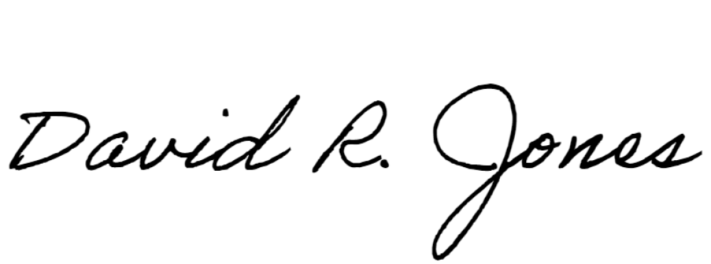
All inquires should be directed to:
Signed:
"Randy" David R. Jones, AIA Project Manager - Architect Planning, Design and Construction Appalachian State University 2458 Hwy 105 S.
Boone, NC 28607
Office: 828-262-7531

