ADVERTISEMENT FOR BIDS

Sealed proposals will be received until 1:00 pm on Thursday, March 26, 2026, in the Appalachian State University Planning, Design and Construction large conference room at 2458 NC Highway 105, Boone, NC for the construction of New River Light and Power Oak Grove Substation Misc. Repairs project at which time and place bids will be opened and read.
Complete plans and specifications for this project can be obtained from:
Dewberry Engineers Inc.
9300 Harris Corners Parkway, Suite 220
Charlotte, NC 28269-3797
(704) 509-9918
during normal office hours after February 24, 2026.

Plans and specifications are also available via email from Joe Fulk, PE at jfulk@dewberry.com
A non-mandatory pre-bid meeting will be held for all interested bidders at 10:00 am on Wednesday, March 11, 2026 at 438 Hodges Gap Road, Boone, NC 28607.
Copies may be obtained from Dewberry Engineers Inc. upon deposit of one hundred dollars ($100) in cash or certified check. The full plan deposit will be returned to those bidders provided all documents are returned in good, usable condition within ten (10) days after the bid date.
The state reserves the unqualified right to reject any and all proposals.
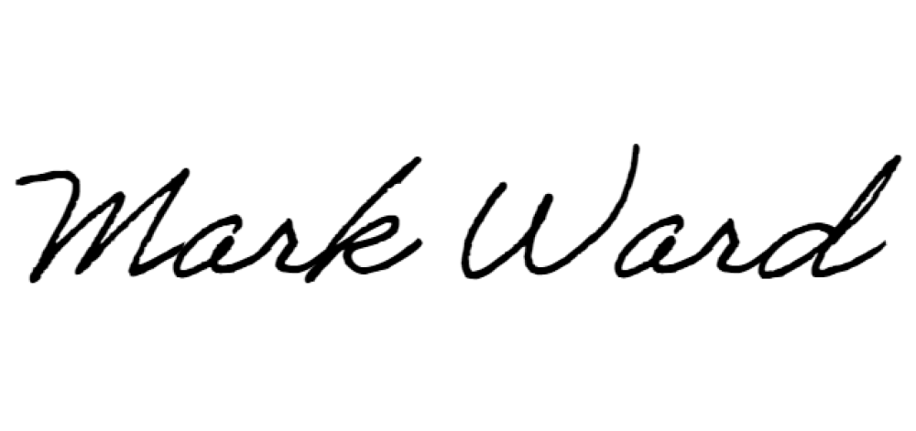
Signed: Mr. Mark Ward, PE

