

2020 – 2021 Strategic Energy and Water Management Plan

September 2020

Table of Contents
Executive Summary 3
Sustainability Commitments 6
Greenhouse Gas Emissions 7
Facility Emissions 7
Vehicle Emissions 8
Energy and Water Use 9
Energy Use Intensity 9
Water Use Intensity 11
Energy and Water Expense 12
Campus Energy Portfolio 15
On-Campus Renewable Energy 16
New River Light and Power 17
University Vehicles 17
Specific Efficiency Measures 18
Project Funding 18
2019/20 Completed Efficiency Projects 19
Potential Future Efficiency Projects 20

Executive Summary
Appalachian State University has a long-standing commitment to sustainability. Various university commitments and state mandated benchmarks, as described on page six, lead towards one overarching goal, climate neutrality.
Defining climate neutrality requires determining the environmental impacts of a wide variety of inputs. For the purpose of this Strategic Energy and Water Management Plan (SEP), the focus on climate neutrality is defined in relation to the university’s energy and water consumption. Appalachian State University’s Office of Sustainability has a broader focus that encompasses additional considerations such as the impacts of food consumption, commuting, material sourcing, etc. This SEP is written with the long-term goal of eliminating energy and water-related greenhouse gas emissions by 2050. This target year is set as the latest possible timeline and used as a way of measuring progress. Energy and water reductions are intended to be made as aggressively as possible.

Strategic Planning
A data driven analysis of the university’s annual energy and water use provides an opportunity to evaluate university consumption, identify issues, and prioritize opportunities that can help the university reach its carbon neutrality goals. Establishing specific, measurable, attainable, and realistic energy and water goals allows for the development an informed strategy.
The 2020/21 SEP evaluates three target areas for the period from July 2020 through June 2021.
- Greenhouse Gas Emissions
- Energy and Water Use
- Energy and Water Expense

Year in Review - 2019/20
The 2019/20 school year was unprecedented. The COVID-19 pandemic effectively shut down the university for the last four months of the academic year. Consumption levels during this time do not reflect a fully occupied campus and are likely to increase with the return of campus activities. It is important to note that prior to the campus shutdown, there were a significant number of efficiency measures implemented that aided in the reduced utility consumption.
Figure 1. 2019/20 Energy and Water Reduction Goal Results

2019/20 Goal | Reduction Goal | Actual Reduction | Pre-COVID  Reduction
Reduce Facility Greenhouse Gas Emissions | 17% | 9% | 4%
Maintain Vehicle Green House Gas Emissions | 0% | 15% | 6%
Reduce Energy Use Intensity | 20% | 9% | 6%
Reduce Water Use Intensity | 3% | 25% | 8%
Reduce Raw Energy Cost | 3% | 17% | 15%
Reduce Water and Sewer Cost | 3% | 6% | Increased 10%

As noted in Figure 1, the COVID shutdown reduced energy and water consumption rates and expenses. However, pre-COVID consumption levels and expenses through the end of February 2020 were already significantly lower than the previous year. This can be attributed to the large number of installed on-campus efficiency measures and a significant reduction in price per kWh beginning in March 2019.
Figure 2 shows the specific totals for each of the 2019/20 energy and water goals as compared to 2018/19 levels.
Figure 2. 2018/19 and 2019/20 Totals for Energy and Water Consumption

 | 2018/19 Totals | 2019/20 Totals
Facility Greenhouse Gas Emissions | 42,036 MT eCO2 | 37,833 MT eCO2
Vehicle Green House Gas Emissions | 265 MT eCO2 | 226 MT e CO2
Energy Use Intensity | 94 kBTU/sq.ft. | 81 kBTU/sq.ft.
Water Use Intensity | 17.1 gal/sq.ft. | 12.8 gal/sq.ft.
University Energy Expense | $6.8 million | $5.6 million
Water and Sewer Expense | $1.2 million | $1.1 million

Looking Forward
The 2020/21 school year presents a number of challenges and opportunities. The university must ensure student, faculty, and staff safety with limited funding. While the energy savings during the four-month shutdown helped the university achieve many of the goals outlined in the 2019/20 SEP, some of these reductions are likely temporary and will increase as campus activities resume.

In addition to encouraging social distancing and proper hygiene and sanitation, the university increased the amount of outside air being supplied by the heating, ventilation, and air conditioning (HVAC) systems that are capable of operating in this manner. Increasing the amount of outside air allows for increased ventilation but most HVAC systems were designed to recirculate already conditioned air.
More outside air requires not only conditioning in coming air but it also requires controlling humidity.

In order to balance the increased energy consumption of HVAC systems, the university is ensuring HVAC systems and schedules are as efficient as possible. The challenge for managing energy and water use will be to move forward with implementing low-cost, operational efficiency measures while preparing project proposals for more costly improvements when funding does become available. With such unusual COVID-related challenges and uncertainties, the 2020/21 SEP attempts to set achievable energy and water goals while keeping in mind that the previous year’s usage numbers are likely to increase significantly.

2020/21 Energy and Water Goals

- Reduce facility greenhouse gas emissions by 4.7% from 2019/20 levels.
- Reduce vehicle greenhouse gas emissions by 5% from 2018/19 levels.
- Reduce energy use intensity by 11% from 2019/20 levels.
- Reduce water use intensity by 5% from 2018/19 levels
- Reduce energy expenses by 2.5% from 2018/19 levels.
- Reduce water expense by 2.5% from 2018/19 levels.
- Reduce sewer expenses by 6% from 2018/19 levels.

Strategies to Achieving Energy and Water Goals
This SEP contains a list of some of the recently completed and potential efficiency projects that will help the university achieve its goals. By identifying a wide variety of projects that range in scope and cost, the university can be prepared to move forward when particular funding opportunities become available.

Sustainability Commitments and State Mandates
The following provides a brief background on several university and state-mandated initiatives that guide university energy and water consumption goals in this SEP.

American College & University Presidents’ Climate Commitment – 2008
- Toward Climate Neutrality - Developed in 2010 by Appalachian State University’s Sustainability Council and endorsed by Chancellor Kenneth Peacock, this document highlighted the complex realities that would be required for the university to achieve climate neutrality by 2050.¹
- Second Nature Climate Commitment - Signed by Chancellor Sheri Everts in 2016, this is a commitment from Appalachian State University to reach climate neutrality by 2050.²
- Faculty Senate – Passed a resolution to achieve climate neutrality by 2035.³
- North Carolina Senate Bill 668 – Passed in 2007, SB 668 promotes the conservation of energy and water use in state, university, and community college buildings. New buildings must be built 30% more energy efficient, renovations must be 20% more energy efficient, and water efficiency in new buildings must be improved by 20%.⁴
- House Bill 1292 - 2009 – HB 1292 allowed institutions of the University of North Carolina to carryforward unspent annual utility funds that could be documented as a result of installed energy conservation measures. Once awarded, those funds can be spent during the following fiscal year, 60% of which must go towards additional efficiency measures.⁵
HB 1292 also created state requirements to ensure that states are tracking energy and water consumption data as well as regularly updating strategic energy plans.
- The UNC Policy Manual – In 2013, the UNC System stated that UNC institutions must develop plans to become carbon neutral as soon as possible and 2050 at the latest. The Policy Manual also states that climate neutrality is the ultimate goal. ⁶
- Executive Order No. 80 – In 2018 Governor Cooper established North Carolina’s Commitment to Address Climate Change and Transition to a Clean Energy Economy. The plan called to reduce statewide greenhouse gas emissions to 40% below 2005 levels, increase the number of state-owned and leased zero emission vehicles to 80,000, and reduce the energy consumption per square foot in state owned buildings by 40%.⁷
For the purpose of this SEP, the goal of climate neutrality by 2050 is used as the metric for reducing energy and water usage and emission levels. This year is select so that annual reduction goals can be assigned. This timeline will not be a limiting factor as reductions in energy and water use will be pursued as aggressively as possible.

¹ https://sustain.appstate.edu/_documents/Toward%20Climate%20Neutrality.pdf
² https://secondnature.org/signatory-handbook/the-commitments/#climate-commitment
³ https://today.appstate.edu/2019/12/20/climate-neutrality
⁴ https://www.ncleg.gov/Sessions/2007/Bills/Senate/PDF/S668v0.pdf
⁵ https://www.ncleg.gov/Sessions/2009/Bills/House/PDF/H1292v0.pdf
⁶ https://sustain.appstate.edu/_documents/UNC-System-Sustainability-Policy.pdf
⁷ https://www.ncdhhs.gov/about/department-initiatives/climate-change-and-clean-energy-plans-and-progress

Greenhouse Gas Emissions
In order to achieve climate neutrality, net greenhouse gas (GHG) emissions will need to be effectively reduced to zero metric tons of equivalent carbon dioxide (MT eCO2) by 2050. In order to eliminate university GHG emissions, a realistic understanding of current emission levels and annual reduction goals is required. The GHG emissions in this SEP include the emissions that come from purchased electricity and fuels burned in university facilities and vehicles. Other GHG emissions related to the university are tracked by the Office of Sustainability.
GHG emissions in this SEP are broken down into two categories: facilities and vehicles. Facilities includes all campus buildings and other infrastructure that consumes energy (leased facilities, parking lots, athletic fields, etc.) Vehicles includes motor pool utility trucks owned by the university and motor fleet passenger vehicles that are leased.

Facility GHG Emissions
As indicated in Figure 1, Appalachian State University has seen continued reductions in GHG emissions. While these reductions are important, significant work remains.
- 2018/19 Facility Greenhouse Gas Emissions - 42,036 MT eCO2
- 2019/20 Facility Greenhouse Gas Emissions - 37,833 MT eCO2

The 2019/20 SEP established a goal of reducing facility GHG emissions by 17%. Actual reduction for the year was 8.7%. The COVID-19 campus shutdown demonstrates the magnitude of change that is required to achieve dramatic emission reductions.
As pictured in Figure 2, While installed efficiency measures and the campus shut down allowed the university to reduce its facility GHG emissions 4,203 MT eCO2, the total facility GHG emission levels for the year remained slightly higher than the target goal set for achieving climate neutrality by 2050.
Facility GHG Goal - In order to meet the 2020/21 facility GHG target goal of
Figure 3. Facility GHG Emissions Compared to Net Zero by 2050 Target Emissions
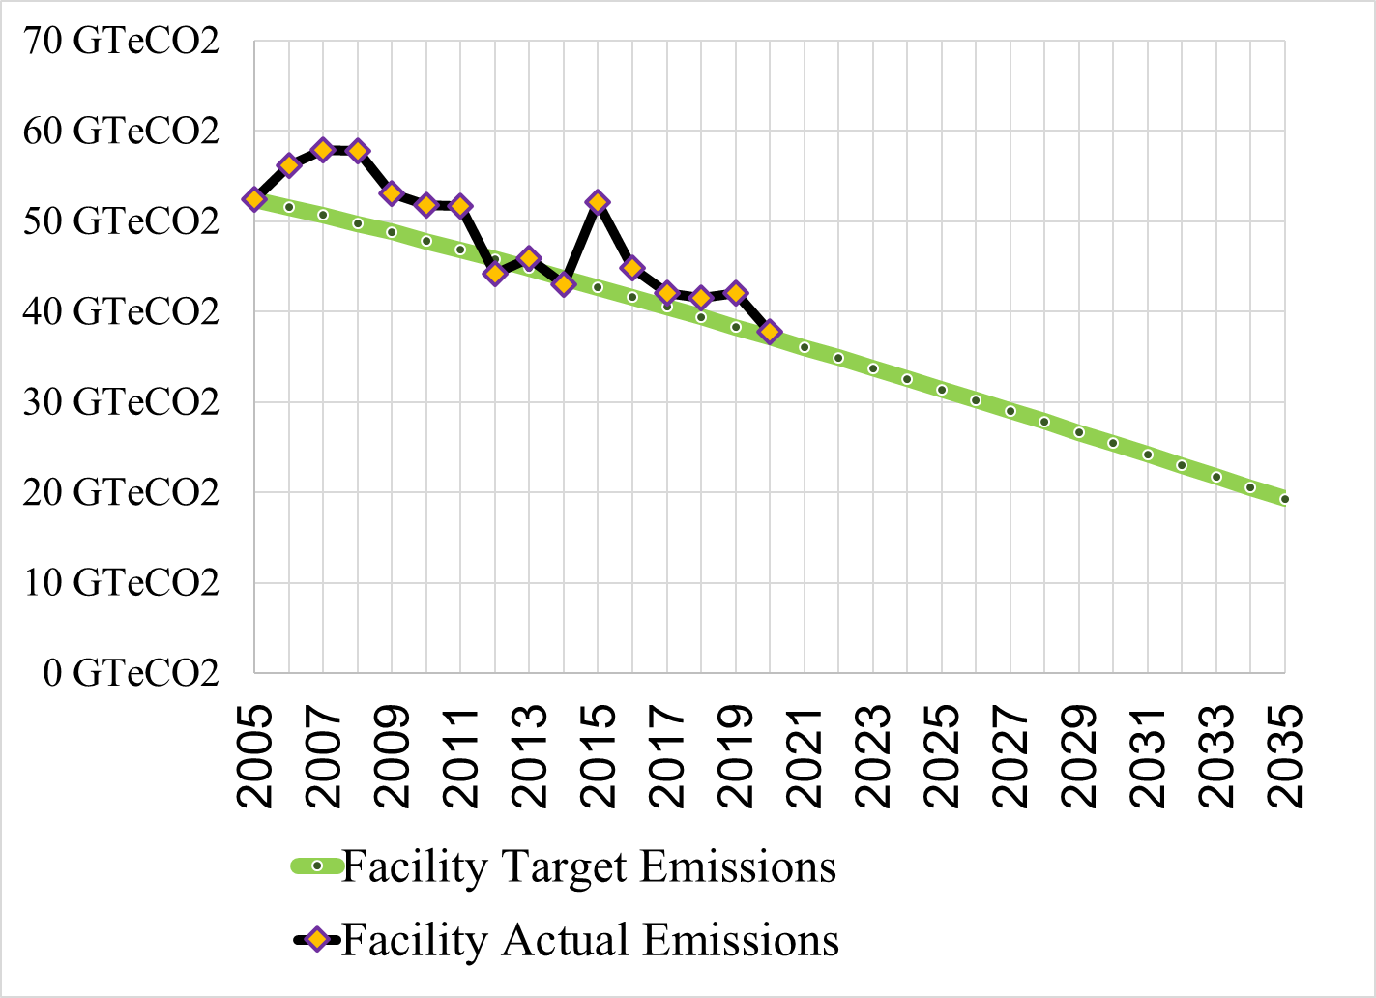

36,050 MT eCO2, the university would have to reduce GHG emissions by an additional 4.7% as compared to 2019/20 levels. With last year’s emissions not representing a fully occupied campus and increased energy demands from increasing outside air ventilation, a 4.7% reduction in facility emission will likely present a significant challenge.
SIMAP® is the greenhouse gas tracking tool used by Second Nature participating schools and universities. 2019/20 facility electrical consumption created 23,027 MT eCO2 while steam production

was responsible for 14,806 MT eCO2. In terms of reducing greenhouse gas, reducing electricity consumption should be prioritized.

Vehicle GHG Emissions
The emissions from the university’s owned and leased vehicles continued to decrease with a 15% reduction in 2019/20. While this trend is in-line with goals set to achieve carbon neutrality by 2050, significant investment in energy efficient vehicles will be required to sustain vehicle emission reductions.
- 2018/19 Vehicle GHG emissions 265 MT eCO2
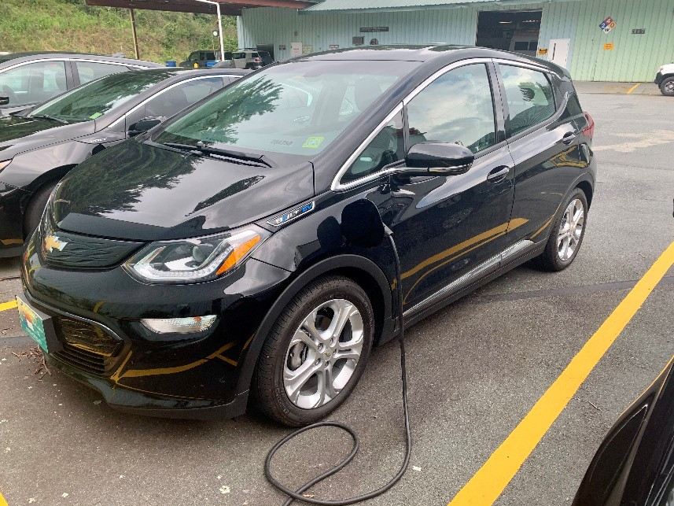
- 2019/20 Vehicle GHG emissions – 226 MT eCO2 The university increased the number of
Figure 4. 2020 Chevrolet Bolt (EV)
electric vehicles (EV) in its fleet but a formalized vehicle efficiency plan is needed. With increased production and availability, electric vehicles will likely play a significant role. While the university’s electrical consumption currently has more significant emission impacts than burned fossil fuels, if the university invested in developing renewable energy systems and purchased renewable sourced electricity, there would be an opportunity to eliminate vehicle-related emissions if the motor pool and motor fleet become all electric. Before a
long-term strategy can be implemented that lays out an EV replacement goal, the university would benefit from at least one year of operations and maintenance with the existing fleet of electric vehicles.
2020/21 Vehicle Emissions Goal: Reduce emissions by 5% compared to 2018/19 levels and begin developing a long-term vehicle replacement plan.
It is important to note that these emission figures do not include AppalCART, the public transportation system, jointly owned by the university and Town of Boone, or commuting from student, faculty, and staff. These emissions are tracked and included in the Office of Sustainability’s Climate Action Plan.

Energy and Water Use
Appalachian State University’s campus is approximately 5.6 million square feet and requires significant amounts of energy and water so that occupants are comfortable and safe. During 2019/20, the university increased in size by almost four hundred thousand square feet while reducing total energy and water consumption. Energy and water consumption is detailed as follows:
- 48,683,266 kWh of electricity - 10% reduction from 2018/19
- 2,867,627 therms of natural gas – 7% reduction from 2018/19
- 12,345 gallons of propane – 26.5% reduction from 2018/19
- 572 gallons of number 2 fuel oil – 46% reduction from 2018/19
- 72,084,000 gallons of water – 20% reduction from 2018/19

Shutting down the campus in response to the COVID-19 pandemic certainly reduced consumption but it is important to note that Facilities Operations implemented a number of energy saving projects in 2019/20. With the campus activities resuming during the fall 2020 semester and the increased energy demand on HVAC systems from increased outside air ventilation, it’s difficult to provide exact estimates but energy numbers are expected to return comparable to pre-COVID-19 levels and may even increase depending on how long increased outdoor air use is implemented.

Because buildings vary to such a degree in size, use, and design, comparing the amount of energy and water between buildings becomes difficult. Energy use intensity and water use intensity allows different types of buildings to be compared. Anything that uses energy (lighting, heating, etc.) is counted and compared to the square footage of the campus. This including dormitories, athletic facilities, student services, parking decks, leased facilities, chiller plants, etc. The target usage intensities are dependent on three major factors: total energy and water consumed, total facility square footage, and the GHG energy mix.

Energy Use Intensity
Energy use intensity (EUI) allows the university to compare and track energy use of various different types of facilities on campus. In this report, EUI is expressed as energy use per square foot.
- 2018/19 EUI - 93,939 BTU per square foot (BTU/sq.ft.)
- 2019/20 EUI - 80,894 BTU/sq.ft.
EUI reduction goals for 2019/20 were to reduce EUI by 19.9% compared to the previous year. This would have reduced the energy demand by 18,678 BTU per square foot. Actual EUI was reduced 9.2%, a reduction of 13,045 BTU per sq.ft.. Even though the university significantly reduced EUI, the 19.9% goal was not achieved. This ambitious goal highlights the need to significantly reduce energy consumption in campus buildings to be on track towards achieving climate neutrality by 2050.

EUI Goal for 2019/20 - Figure 4 compares the university’s actual EUI with a target EUI incremental reduction goals that set a path towards climate neutrality. There has been a sustained reduction since the 2005 baseline year. To meet the 2020/21 EUI goal, the university would have to reduce the EUI 11% from 80,894 BTU/sq.ft. in 2019/20 to 72,060 BTU/sq.ft.
With the increased demand for ventilation amid the response to COVID-19, EUI will likely increase as the university’s HVAC systems will be required to operate more frequently as systems balance the
Figure 5. Actual and Target Energy Usage Intensity
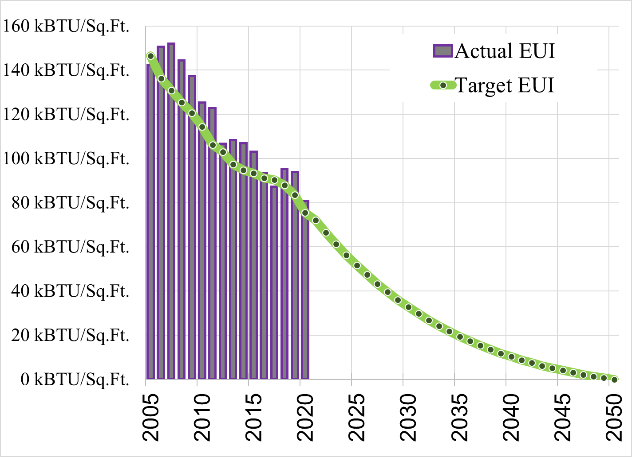

needs of bring in fresh air with balancing temperature and humidity requirements. Dehumidification of large facilities requires significant amounts of energy. During warmer months, incoming outside air is warm and humid. Air conditioners cool incoming air but reheating systems must be used to achieve desired indoor humidity levels.
Facilities Operations will continue to prioritize the efficiency of academic and administrative buildings by optimizing HVAC operations, ensuring building schedules match actual occupancy schedules, and pursuing efficiency projects as funding allows. Implementing energy efficiency projects is key to reducing EUI but ensuring that newly constructed campus buildings are designed and constructed with aggressive energy efficiency standards would have an even bigger impact on the university’s future EUI.

Water Use Intensity
Similar to EUI, water use intensity (WUI) analyzes water consumption across the entire campus. In this report, WUI is expressed in gallons per square foot.
- 2018/19 WUI – 17.1 gallons per square feet (gal/sq.ft.)
- 2019/20 WUI – 12.8 gal/sq.ft.
Figure 5 tracks the university’s WUI since the 2002/03. The amount of water consumed on campus has decreased since then due to increased attention to maintenance like eliminating leaks and installing low flow fixtures.
Unfortunately, the WUI has been largely flat for the last eight years.

Figure 6. Water Usage Intensity History
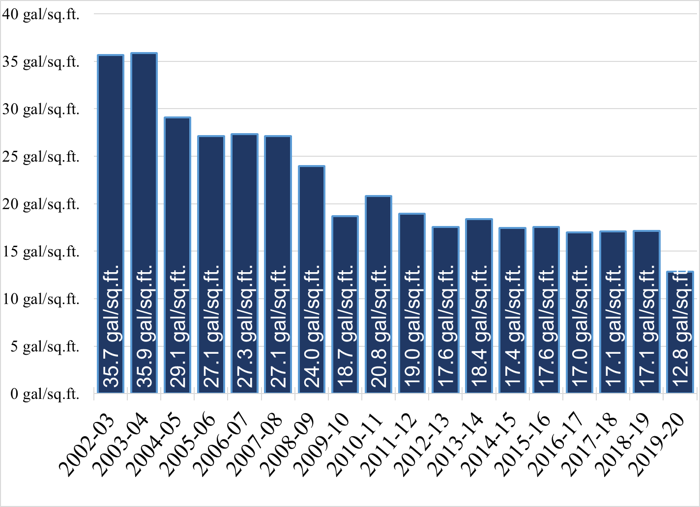

During 2019/20, there was a dramatic 25% decrease in water use intensity. Facilities Operations was able to keep most buildings’ HVAC systems off except for a couple hours per day during the campus shutdown.
Many campus air conditioning systems rely on cooling towers that use the evaporation of water to remove heat. By significantly reducing the operation of air conditioning during the COVID shutdown, the university realized significant water consumption savings. Combined with almost no direct consumption from students, faculty and staff, the WUI decreased significantly.
WUI Goal for 2020/21 - As with EUI, WUI is expected to increase as the university resumes campus activities. Increased dehumidification of outside air will likely increase water consumption but on-campus dormitory residency rates are only at 85% of capacity for the fall semester so there will likely be decreased water consumption at residence halls.
In order to continue track the long term WUI trends while also being realistic about the most recent WUI reductions, the university will set the goal to reduce WUI 5% from 2018/19 levels.

Energy and Water Expense
The amount of energy and water required by the university creates significant financial obligations and must be considered when determining future strategies. Reducing utility costs for the university helps strengthen resiliency during financially difficult periods as is evident with current situation.

Energy
As seen in Figure 7, the total annual energy expense was reduced 17% from 2018/19 to 2019/20. By implementing various efficiency measures and also shutting down most university buildings for four months, the university was able to reduce total energy costs by $1.2 million compared to 2018/19.
- 2018/19 Total Energy Expense - $6,808,764
- 2019/20 Total Energy Expense - $5,655,362
These figures include the amount of electricity purchased from New River Light and Power as well as the cost of fossil fuels consumed at the steam plant and other places on campus. Also included in the steam costs are associated repairs and maintenance and other operational costs.

Figure 7. Total Annual University Energy Expense
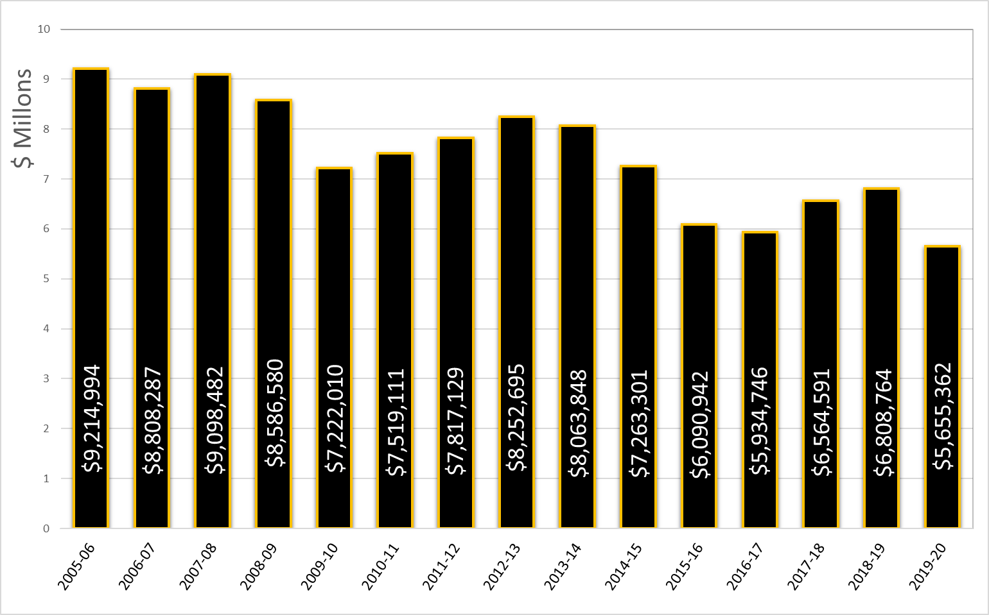

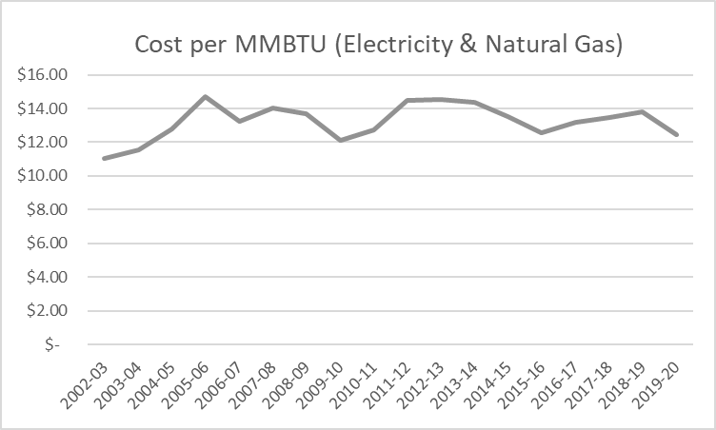
The cost of energy has a direct impact on the university’s overall energy costs. There has been a marked decline in the amount of energy consumed and the total amount spent on energy but the combined cost of electricity and natural gas (measured in $/ MMBTU) has not had a discernable trend. With various factors
affecting the costs such as fuel supply, weather, and governmental complexities, the price of energy over the last 18 years makes predicating future energy costs difficult. The conventional assumption is that the long-term cost of energy will increase but as the adoption of renewable energy increases and as the commercially-available supply of natural resources fluctuates,
predicting future energy prices remains challenging.

Figure 8. Historical Cost per MMBTU of Energy

Water and Sewer
The university has two costs associated with the water that is consumed on campus, water supplied and disposal or sewer costs. The majority of campus receives water from the university owned and operated water plant and the Town of Boone supplies water to 14 additional meters. The Town of Boone charges sewer fees for all of the water consumed on campus.

- 2018/19 Water Cost - $675,396
- 2018/19 Sewer Cost - $524,091
- 2019/20 Water Cost - $710,041
- 2019/20 Sewer Cost - $415,041

Water expenses have built in overhead and repair costs that are not necessarily correlated to the amount of water consumed.

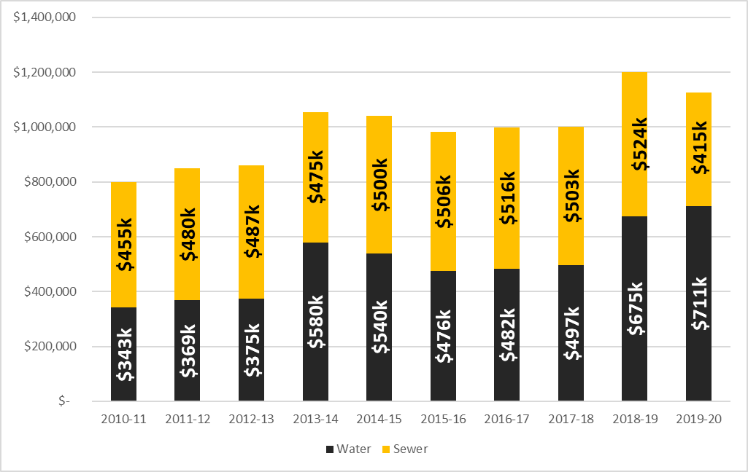
In 2019/20 water costs increased 5.2% as compared to 2018/19. Sewer
expenses track linearly with consumption. Sewer costs in 2019/20 were reduced 20.8% as compared to 2018/19.

Utility Expense Goals for 2019/20
As previously mentioned, increased outside air for campus HVAC systems will increase the amount of energy and water consumed on campus. Providing clear estimates of the expected increase in energy and water use is challenging.
Figure 9. Water and Sewer Costs by Year

- Energy Expense – With little precedence, estimating the expense of operating HVAC systems with increased outside air is challenging but preliminary estimates for increased costs range between 25% and 35%. Because some buildings are limited by the design of the mechanical system, outside air ability is limited, especially when outside temperatures are below 40 degrees Fahrenheit.
The university is working to optimize building schedules that reflect reduced operating hours during nights and weekends. Additionally, the length of semesters has been shortened so that winter break will begin after Thanksgiving. The start of spring semester has also been delayed. This will allow Facilities Operations to shut down campus for nearly eight weeks, which will create financial savings.
2020/21 Energy Expense Goal - Balancing the increased energy requirements with shorter semesters and relatively stable anticipated energy costs, a realistic goal is to reduce energy costs by 2.5% from 2018/19 expense levels which represents the last full year of a fully occupied campus.
- Water Expense – University water expense incorporates a number of factors that are different form energy. Because the university owns and operates a water plant that serves the majority of campus, there are fixed operational costs that are not directly linked to consumption and the price of water per gallon has been increasing over the past several years.
2020/21 Water Expense Goal : Reduce water expense by 2.5% based on 2018/19 totals.
Sewer Expense – While sewer costs are connected to water consumption, Facilities Operations is in discussions with the Town of Boone to explore the possibility of instituting an evaporation credit. Cooling towers use large amount of water but the vast majority of that water evaporates int the atmosphere.
2020/21 Sewage Expense Goal: Reduce sewer expenses by 6% based on 2018/19 totals.

Campus Energy Portfolio
Steam and electricity are the two primary types of energy used to operate campus facilities. The university’s steam plant primarily operates on natural gas and uses fuel oil as a backup fuel source. University-owned New River Light and Power purchases electricity from Blue Ridge Energy who purchases power from Duke Energy. A small portion of energy is provided by on-campus renewable energy systems.
Total energy consumed on campus during 2019/20 was 453,729 MMBTU. This includes both steam and fossil fuel consumption. The following figure provides a breakdown of the sources of total energy (electricity, steam, and other heat) based on-campus fossil fuel usage and Duke Energy’s portfolio⁸.

Figure 10. Facility Combined Energy Portfolio
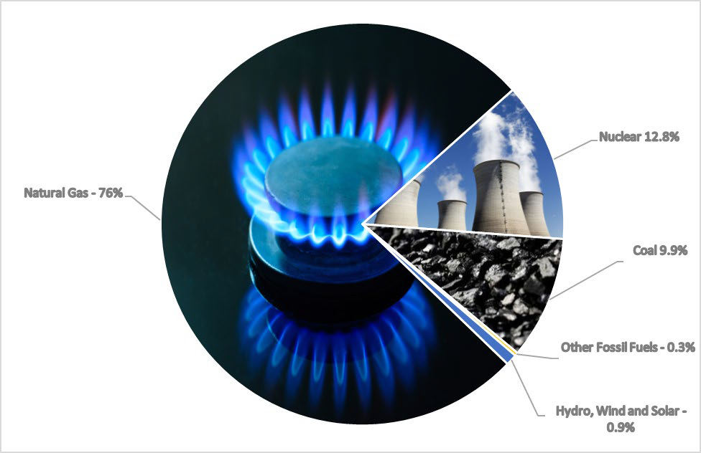

⁸ https://www.duke-energy.com/annual-report

On-Campus Renewable Energy
The university has several renewable energy systems on campus. Appalachian State University’s Renewable Energy Initiative (ASUREI), a student-led, student-funded committee has been the primary funder of renewable energy installations to date.
During 2019/20, on campus renewable energy systems produced 236,074 kWh of electricity and 569 MMBTUs from functioning solar thermal systems. On campus renewable energy provided 0.18% of the university’s total energy use. Figure 10 details the breakdown of on-campus renewable energy.

Figure 11. On Campus Renewable Energy Portfolio
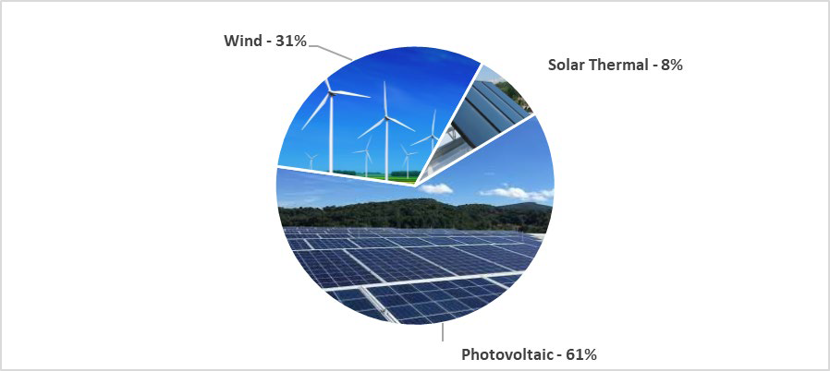

Unfortunately, there is significantly more solar thermal capacity installed on campus than what is being operated. The lack of utilization has been due to unanticipated maintenance costs and labor requirements to keep systems operational. Less than 10% of the total solar thermal capacity on campus was operating in 2019/20. Due to limited site and resource availability as well as the associated maintenance costs of wind energy, the university is currently prioritizing photovoltaic (solar electric) as the preferred on-campus type of renewable energy system.
Figure 12. On-Campus Renewable Energy Production 2019/20

 | Annual Production
Broyhill Wind Turbine | 89,240 kWh
Leone Levine Photovoltaic (PV) | 79,204 kWh
Legends Electric Vehicle Charging Station PV | 7,520 kWh
Library Traffic Circle PV | 6,254 kWh
Frank Hall PV | 49,268 kWh
Kathrine Harper/Kerr Scott PV | 1,444 kWh
Peacock Hall Mountain PV | 3,144 kWh

New River Light and Power
While not occurring until 2022, changes in how electricity is purchased and provided to New River Light and Power (NRL&P) will lead to an ability to choose purchased electricity by fuel source. Under the current structure, NRL&P purchases electricity from Blue Ridge Energy who is supplied electricity from Duke Energy. Currently, Duke Energy does not offer an option to choose the source of electricity.
NRL&P negotiated to purchase electricity from NTE Carolinas LLC (NTE) beginning January 2022. The contract with NTE will provide greater flexibility in determining the university’s energy portfolio, implement time of use peak demand fees, and remove limitations on the amount of new renewable energy systems that can be added to the grid. Electrical prices are anticipated to go down with NTE when purchasing fossil fuel-sourced electricity. If the university opts to purchase renewable energy, prices will increase but also create the opportunity to substantially reduce the university’s climate footprint.⁹
Peak Demand, the instantaneous amount of electrical power being consumed, will create an opportunity and challenge for the university under the NTE contract. Currently there is no time of use fee associated with peak demand and the university is charged based on the highest monthly occurrence. With time of use fees, there will be periods throughout the day that cost more to consume electricity. This creates the opportunity to shift loads to reduce utility costs. This will require significant planning to ensure the university has access to reliable, real-time metering.

Motor Pool /Fleet Vehicles
Under UNC System guidelines, Appalachian State University may only purchase approved utility vehicles. These purchase vehicles are referred to as the motor pool. The motor pool is limited to purchasing 12 passenger vans, box trucks, cargo vans, pickups trucks, and other large utility vehicles unless given special permission by the North Carolina Department of Administration. Passenger vehicles such as sedans, minivans, and sports utility vehicles are leased and are referred to as the motor fleet.
With a relatively low amount of daily mileage, electric vehicles would likely be suitable replacements for most campus requirements. In order for the university to purchase electric utility vehicles, the Department of Administration has to approve specific vehicles that the university is allowed to purchase. In order to reduce emissions and strengthen the argument for purchasing electric utility vehicles, the university has begun to lease electric vehicles (EVs).
During the 2019/20 fiscal year, the university replaced four older Chevrolet Impalas with four all-electric Chevrolet Bolts. The university also traded a Chevrolet Impala for a plug-in hybrid Chevrolet Volt the previous year. The remaining fleet consists primarily of Ford Focus and Ford Fusion sedans and Chevrolet Grand Caravan minivans.

⁹ https://today.appstate.edu/2020/02/27/nrlp

In addition to reduced point source emissions, savings from fuel and maintenance costs are expected to offset increased vehicle price. Establishing successful year-round operation of the all-electric motor fleet vehicles will strengthen the argument that the Department of Administration should allow electric light duty trucks to be purchased once they become commercially available. The Motor Pool intends to increase the number of electric vehicles as older vehicles are retired but there has yet to be a specific goal determined for the number of EVs acquired per year. Before finalizing an official replacement goal for the number of EV’s purchased per year, the university would benefit from examining current EVs in regular use for at least an entire calendar year before determining the number of EV’s that will be acquired each year.
Facilities Operations currently has five charging stations for five plug-in vehicles. As the fleet of EVs increases, the number of charging stations will need to increase proportionally. This represents an added cost that needs to be factored into the life cycle analysis of each vehicle. Manufacturer recommendations for the Chevrolet Bolt state that the vehicle should be plugged in when not in use to optimize battery efficiency. Once fully charged, the vehicle does not continue to consume electricity.

Specific Efficiency Measures

Funding Energy Projects - With COVID-related budget shortfalls, the importance implementing energy and water savings projects is highlighted. Limited project funding will require low-cost projects to be prioritized. This will also provide an opportunity to prepare and prioritize larger capitol energy projects so that when funding does become available, the university can move forward. The following is a list of previously used and potential funding sources for on-campus energy projects.
- Appalachian State University – In addition to student and faculty commitment to sustainability, Facilities Operations has an engrained and pragmatic approach toward efficiency and self-sufficiency. With ongoing operations and maintenance, Facilities staff work to increase the longevity and efficiency of equipment at the university. The university’s HVAC, Controls, Preventative Maintenance, Zone Maintenance, Motor Pool, and Steam shops continue to provide reliable services that extend the lifespan of university-owned facilities and equipment. Facilities Operations intends to continue to make significant investments in energy efficiency as funding allows.
- Energy Saving Performance Contracts (ESPC) – The university has used ESPCs as a way to fund energy measures installed with no upfront cost to the university. The contractor claims savings throughout the life of the savings and while this has been an effective way to get a number of efficiency projects installed on campus, actual savings have been much less than predicted.
Since ESPCs are not responsible for maintenance, reliability and occupant comfort, university staff have devoted significant resources towards troubleshooting installed ESCO efficiency measures.
Alternatively, efficiency measures installed by university staff have reduced energy by 24% with less overhead and have typically resulted in high occupant satisfaction and system reliability. The university is not currently considering ESPCs as a way to fund energy projects.

- Renewable Energy Initiative (ASUREI) – A student-funded and student-operated program that implements on-campus renewable energy systems and energy efficiency projects. The ASUREI has been the primary funder of on campus renewable energy projects and has also contributed to a large number of Facilities Operations efficiency upgrades and projects.
- North Carolina House Bill 1292 – As previously mention HB 1292, provides UNC system schools the opportunity to retain unspent allocated utility funding to be used for energy projects. Colleges and Universities must show that the 1292 savings being claimed have been a direct result of previously installed efficiency projects on academic and administrative buildings.
The university prepared a 1292 application for 2020/21 that identified over $1 million in 1292-eligible energy savings. Unfortunately, the current financial situation will prevent the university from receiving 1292 carryforward fund for the 2020/21 school year.
- Office of Sustainability – The Office of Sustainability engages the campus community to collaboratively and strategically promote sustainability. The Office of Sustainability serves as a resource that can help bridge potential research and funding opportunities with current and future energy and sustainability needs.

2019/20 Completed Energy Projects – The university implemented a number of energy saving projects during 2019/20. This progress was understandably overshadowed by the COVID shutdown but it is important to highlight progress made as these measures will continue to reduce university utility consumption and expense. The following is a list of some of the efficiency projects completed during 2019/20.
- Beasley Media Center – LED replacement lights were installed in the stairwells. Additionally, advanced room scheduling software funded by ASU REI was integrated into the building automation system.
- Garwood Hall – LED lighting was installed in the stairwells and first floor hallway.
- Holmes Convocation Center – Facilities Operations staff installed LED lighting salvaged from the Owen’s Field House. Estimated annual energy savings is 73,584 kWh.
- McKinney Center - Advanced room scheduling software funded by the ASU REI was installed to control HVAC system in two large meeting areas with regularly scheduled events
- Peacock Hall – LED lighting replacements were installed in the second-floor hallways and represent an anticipated 9,829 kWh reduction each year.
- Rankin Buildings (North, South, and West) – Replaced 412 hallway LED lighting fixtures and bulbs. Annual energy savings are expected to be 73,750 kWh.
- Reich College of Education - Advanced room scheduling software funded by the ASU REI was installed to control HVAC and lighting in classrooms with regularly scheduled events. Estimated electrical and heat savings are estimated to be 5%.

- Smith-Wright – LED replacement lighting was installed in the stairwells and elevator in Smith-Wright. Significant updates were also made to the building automation system programming in order to increase HVAC efficiency.
- Student Recreation Center – Significant programming changes enabled the Student Recreation Center to be operationally scheduled in the building automation system. These changes are anticipated to a sustained reduction of nearly 50% when HVAC systems are not running on increased outside air.
- Condensate Return Improvements – The university’s west side of campus is currently the location of a number of construction projects. As these projects progress, there has been a renewed effort to increase the amount of steam condensate that is returned to the system.
- Campus-Wide Holiday Shutdown – During Thanksgiving and Winter holidays, campus buildings were shutdown. Campus wide, these two events avoided the use of 528,462 kWh and 9,182 MMBTU of steam.

Campus-Wide Potential Energy Projects – The following list of identified projects is not intended to be a complete list of projects. As the university balances infrastructure needs with the most cost-effective methods for reducing energy and water usage, GHG emissions, and utility costs, specific funding opportunities can shift priorities. The following list of projects is comprised of projects with various costs and will not all be addressed by the end of 2020/21. For more specific information on a particular project, please to contact energymanager@appstate.edu.
- Temperature and Scheduling Policy - Implement a campus-wide temperature and scheduling policy that applies to all departments (Academic, Administrative, Athletics, Campus Dining, Housing, etc.). This will provide defendable guidance to Facilities Operations when setting up building schedules and temperature setpoints.
- Advanced Room Scheduling – Allows HVAC systems to ‘unoccupy’ specific rooms when not in use. Advanced room scheduling is most appropriate for classrooms, conference rooms, and auditoriums where regularly scheduled events are held. Installed in approximately 15% of the total area of the Plemmons Student Union, there has been an approximate 10% to 15% energy reduction with advanced room scheduling. Advanced room scheduling is currently installed in the College of Education, Beasley Media Complex, McKinney Alumni Center, Plemmons Student Union, and Smith-Wright Hall.
Buildings that are well suited for advanced room scheduling: Garwood Hall, Belk Library, Chapel Wilson, Leone Levine Hall, Holmes Convocation Center, Peacock Hall, Walker Hall (only after HVAC upgrades), and Sanford Hall after the completion of the current renovation.
Advanced room scheduling typically has a simple payback of less than one year and a ROI of more than 100%. There is a considerable amount of time required to research potential new buildings and setup the programming in the building automation system.

- Demand Management - Prepare for changes in peak demand pricing structure that will include time of use fees. This will present opportunities and challenges for the university to reduce energy use during peak times, avoiding higher rates. In order to implement successful demand management, the university will need to work with NRL&P to gain access to more real-time energy data.
- Energy Efficiency Task Force - The Office of Sustainability is forming an efficiency working group comprised of a HVAC/Controls Specialist, the Sustainability Data and Assessment Specialist, and the Energy Manager from Facilities Operations. This teams’ primary goal will be to identify and prioritize opportunities.
- Steam Efficiency Task Force - As part of the 2020/21 Climate Action Plan, the Office of Sustainability and Facilities Operations intend to establish the Efficiency Task Force. This would provide an opportunity to discuss current issues and potential opportunities that may require research and/or funding.

Develop a building re-tuning program
- Develop a long-term renewable energy strategy – Considering the potential to purchase renewable electricity through NRL&P’s CPP contract in 2022, develop a plan that incorporates purchased with renewable energy with potential on-campus renewable energy systems. Current administration preference is to avoid roof top photovoltaic systems based on water penetration and roof lifespan degradation concerns. The university is exploring the feasibility of several ground mounted systems.
- Design Guidelines - Planning, Design & Construction is currently in the process of updating design guidelines for campus renovations and new construction. The university must balance financial limitations with the state-mandated requirement to become climate neutral by 2050. Large renovations create large opportunity to reduce EUI and WUI.
- Ventilation – Demand Ventilation Control – Determine feasibility of installing carbon dioxide, humidity, and temperature transmitters in classrooms to increase indoor air quality and modulate amount of outside air being conditioned.
- Pipe Insulation – Identify piping that need insulation. Steam, condensate, chilled water pipes continually receive maintenance and often insulation is either damaged or not replaced. The university does not employ insulators and currently has to contract out work which can be cost prohibitive.
Known buildings with significant pipe insulation deficiencies: Peacock (condensate), Anne Belk (chilled water), Convocation Center (steam inside lower mech room), Student Rec Center, Edwin Dunkin, Rankin West, Steam Stations

LED Lighting Projects
- Emergency and Stairwell LED Lighting - These lights are on 24 hours a day, 365 days a year but is still largely operating with fluorescent lights .
- 100% LED Lighting - Convert the remaining 1,000 exterior HID lights to LEDs and all interior lights in buildings that are not currently scheduled for demolition. A detailed list has been compiled.
- Review, update, and combine previously compiled lists into one campus-wide non LED lighting list.
- Occupancy Sensors – Determine highest impact areas. Many buildings are still under the performance contract with T8 fluorescent lighting. Determine feasibility of installing occupancy sensors prior to upgrading to LED.

HVAC & Controls
- Determine feasibility of updating sequence of operations based on ASHRAE Guideline 36-2018.
- Turn off domestic hot water and heating hot water pumps when not actively in use.
- Determine if freezing concerns associated with existing plate and frame heat exchanger equipped chillers can be mitigated to improve chiller efficiency.
- Evaluate and potentially implement chilled water and condenser water resets.
- Determine feasibility of enabling optimal stop programming in the building automation system.
- Long term – Implement chiller loops between buildings whenever significant construction occurs.
Chillers are high-energy users that operate best at high loads. Often, one chiller can supply multiple buildings.
- Long term - Eliminate the use of pneumatics actuators and controls in new and retrofit HVAC systems.

Steam Efficiency
- Review results of 2020 feasibility study that evaluated electrification of boilers and alternative fuel sources and determine next steps.
- Install economizer on the number 4 steam boiler. This is the smallest unit and operates the majority of the year. A detailed analysis is required as installing an economizer would likely require an engineering study that balances the unit’s age of life, installation cost, and potential savings.
- Identify areas where condensate return could be improved.
- Continue testing steam traps repair as needed.
- Test all heat exchangers utilizing the latest testing technology and repair any with issues.

- Scan all high, medium, and low-pressure steam valves and lines ultrasonically for leaks. Repair when practical.

Building Specific Opportunities (alphabetical order)
- Anne Belk - Implement improved hot water reset for pneumatically-controlled spaces.
- BB Dougherty - Chiller upgrade and/or replacement. This project would also represent an opportunity to switch to a more benign refrigerant.
- Belk Library HVAC - Update air handling unit (AHU) and variable air volume (VAV) programming.
- Bookstore Chiller Plant – Upgrade chiller to prolong life of unit and ensure continued efficient operation. An additional building automation system controller with sequence of operations and testing will be required. Determine feasibility of chilled water reset and use of plate and frame heat exchanger.
- College of Education – Building automation system improvement of adding a network automation engine (NAE) and six CO2 sensors and implement associated sequence programming
- Edwin Duncan – HVAC and LED Lighting project to increase humidity control and energy efficiency.
- Garwood Hall – Implement an operable scheduling system, currently much of the building operates 24 hours a day. Update VAV sequences to support temporary occupancy. Determine if the Garwood machine shop exhaust system can be separated from the first-floor exhaust system.
Currently the fan operates continuously when it could be controlled manually when needed.
- Holmes Convocation Center: - Install networked arena occupancy sensors to control HVAC system and court and shutter lights. Evaluate potential HVAC upgrades and prepare project proposal.
- John E. Thomas – Chiller upgrade and/or replacement. This project would also represent an opportunity to switch to a more benign refrigerant.
- Rankin West – Upgrade existing chiller to prolong life of unit and ensure continued efficient operation.
- Shaefer Auditorium – Determine feasibility of enabling the chiller’s plate and frame heat exchanger.
- Walker Hall HVAC Upgrades – Improve indoor air quality by increasing the amount of outside air, balance system, and increase thermal storage to reduce the number of times the chiller operates.

Campus-Wide Potential Water Projects
- Evaporation credits - Included in one of the university’s ESPCs, the university has yet to realize the savings associated with sewage fees being based on the amount of water supplied to cooling

towers. While some new metering may be required, determining a path forward with the Town of Boone on evaporation credits would represent a low-cost financial savings opportunity that is common practice for large facilities.
- Conduct campus-wide water audit, identify building specific water efficiency measures, and prioritize project proposals.
- Low flow fixtures - Update urinals and toilets to low-flow fixtures in new buildings and major renovations. A number of older buildings’ sewage systems may not be well-suited for ultra-low flow water devices. Buildings must be evaluated on an individual basis.
- Scheduled test and tunes to ensure toilets, urinals, and faucets are in good order and operating at peak efficiency. This process would be performed once a year in each building on a rotating basis.

- Determine feasibility of closed loop HVAC options that would reduce water consumption.

