A Customer Request is a “Work Request” for Facilities Operations (or Housing, or Motor Pool). Anyone on campus or working for Facilities Operations or Housing can enter a Customer Request as long as they have been given access to AiM and they have the authority to charge work to an Account Number. Account Numbers are specific to a group that AiM calls an Organization – for example “Biology”, or “Housing Operations” – which can have one or more Requestors and one or more Accounts linked to it.

- Go to AiM. https://aim.appstate.edu
- Click on CUSTOMER SERVICE as shown highlighted in yellow.
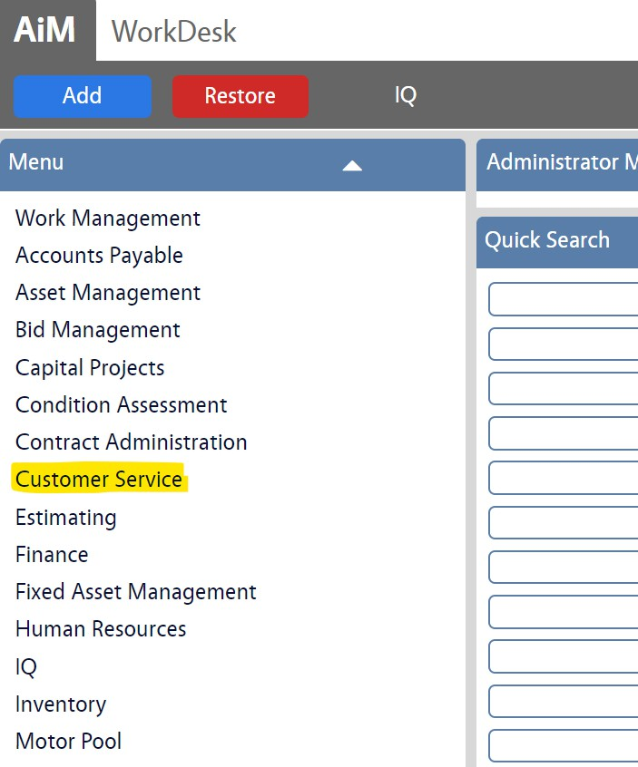

- Click on the NEW icon as shown highlighted in yellow.

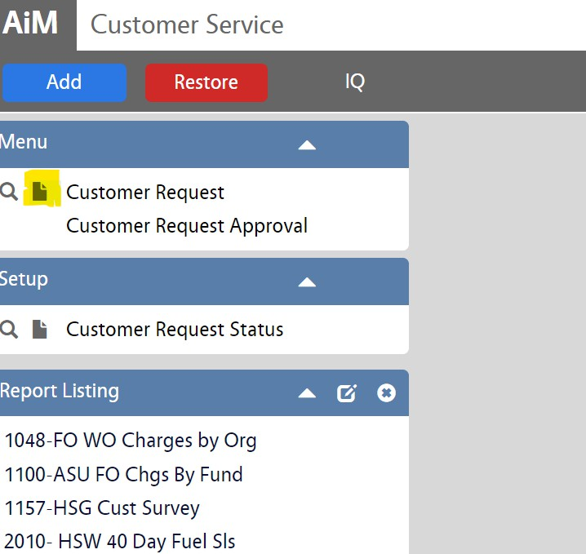

- Under PROBLEM CODE, click on the ZOOM icon (as shown highlighted in yellow) and choose the appropriate code.

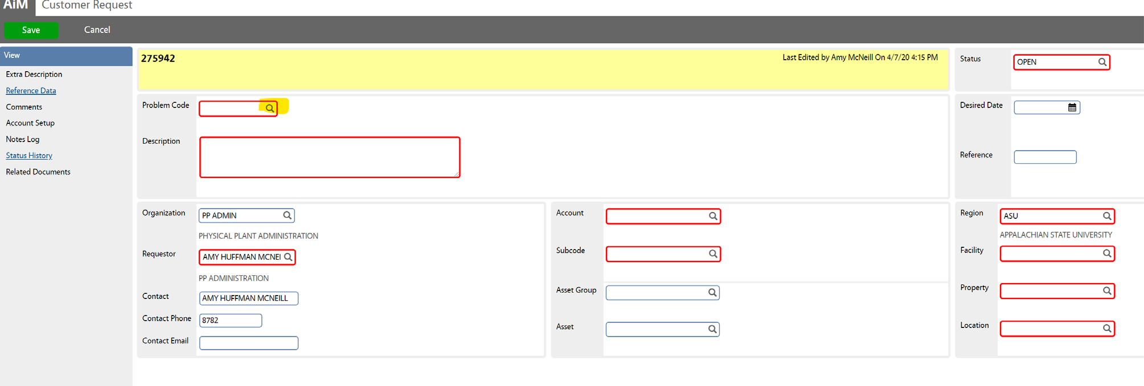

- Enter a description of the problem in the DESCRIPTION field.
- If the request must be completed on or by a specific date, click the CALENDAR icon beside DESIRED DATE (as shown highlighted in yellow) to enter this information.

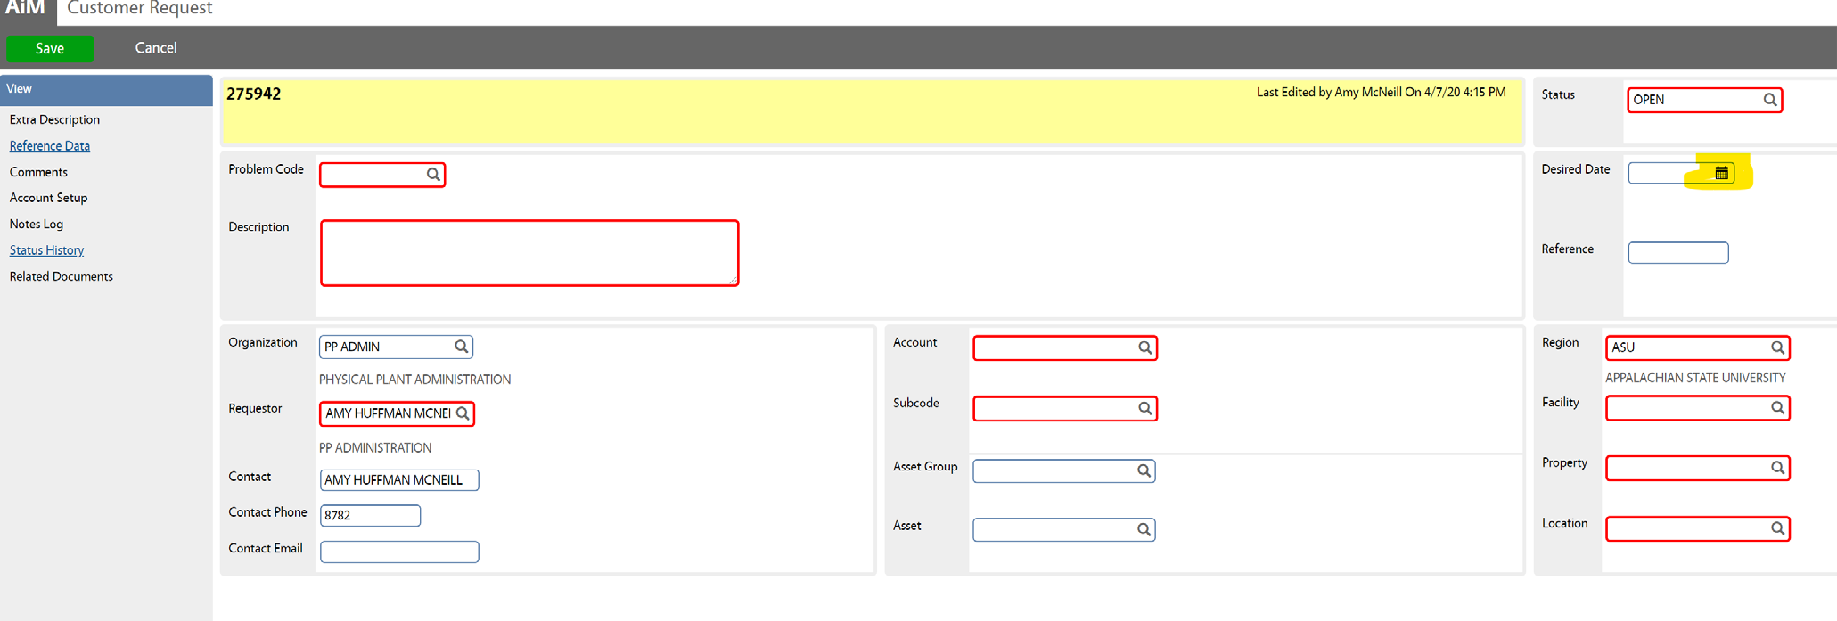

- Your REQUESTOR and ORGANIZATION information should already be filled in by the system (as shown below highlighted in yellow).

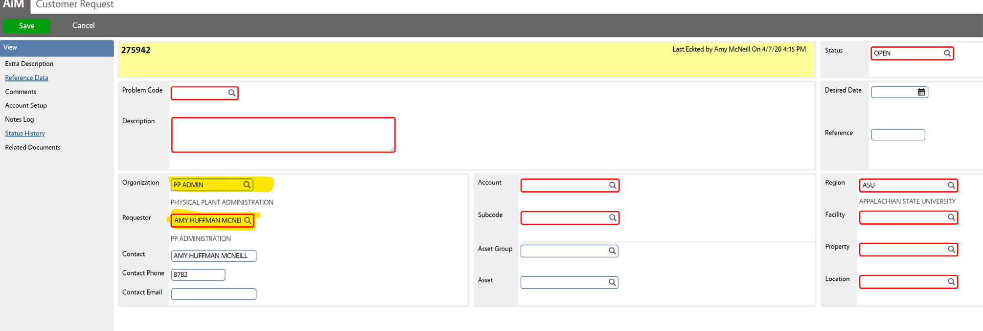

- You can change the CONTACT information and enter the CONTACT EMAIL if someone besides the original contact should receive the work order status update emails. As the requestor, you will already receive the emails (your email address is stored in the system).

- Click the ZOOM icon beside the ACCOUNT field to select the appropriate ACCOUNT (budget code).
- Click the ZOOM icon beside the SUBCODE field to select the appropriate SUBCODE.
- Click the ZOOM icon beside REGION.Select the REGION, FACILITY and PROPERTY.
- Some of this information may already be filled in for you, but click the ZOOM icon next to REGION to select the specific location/room number, if you do not see your specific room number, simply choose your building number with the site code i.e. 359-000. (Please email group-aim@appstate.edu if you do not see your room number.)
- Click the green SAVE button (shown below circled in red) to save the customer request.
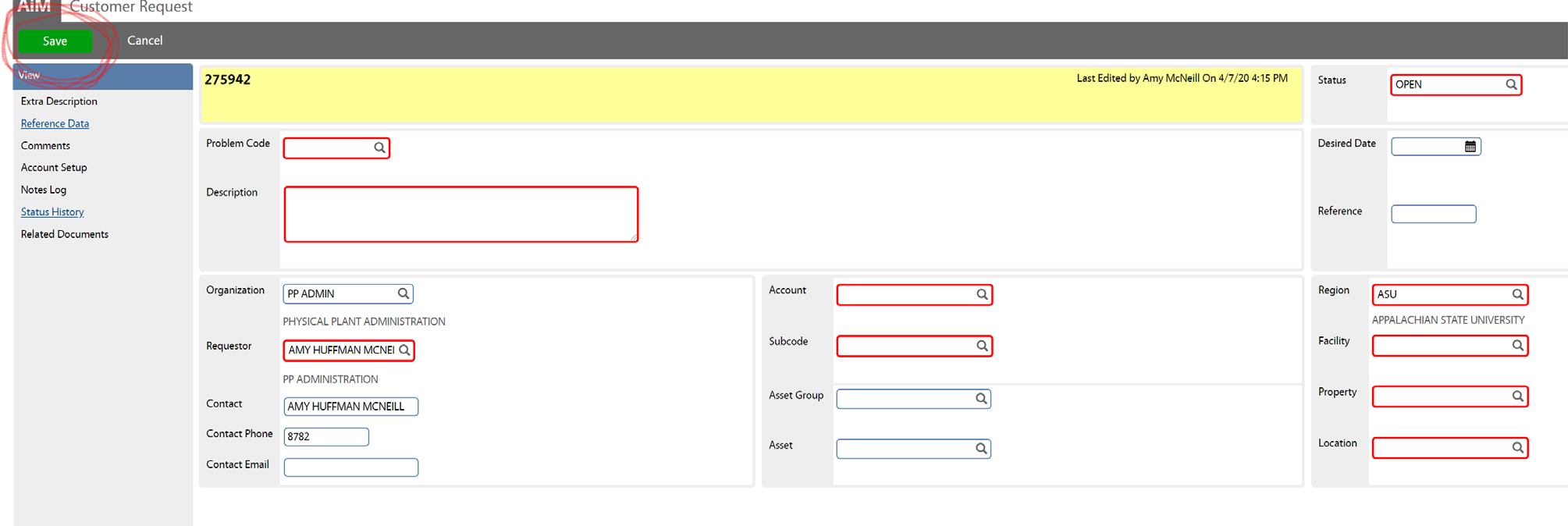

- When you save the Customer Request it is sent directly to Work Control to Work Control In Facilities Operations, Housing Operations, or the Motor Pool where it is approved and turned in to a Work Order.

