There will be 2 ways to access the Central Warehouse Order Form. If you are logged into AiM, you can access it directly through a link on the Facilities Operations or Central Warehouse web page, or you can go directly to http://aim.appstate.edu/whsrequest . If you are logged into AiM you can follow the link on your WorkDesk under Quick Links (CENTRAL WAREHOUSE ORDER FORM). The following instructions start from AiM, but once you link to the form, the steps are the same.
- Log into AiM. Go to the Quick Links section on your WorkDesk. Choose CENTRAL WAREHOUSE ORDER FORM.
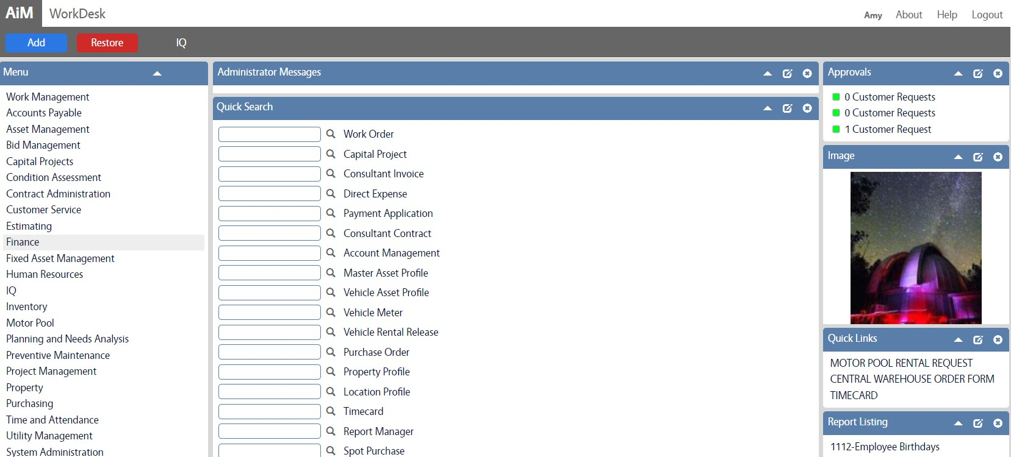

- The Quick Link will take you to the Central Warehouse Request page:
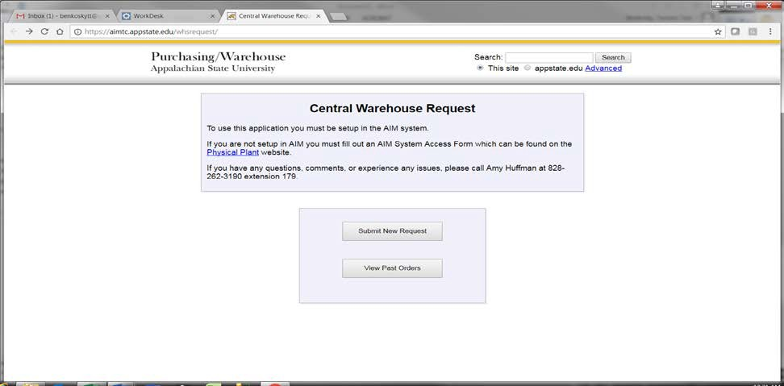

Note that you now have a tab for your AiM WorkDesk and the Central Warehouse Request. You can leave these open and toggle back and forth if you want. A warning, however, if you run a report in AiM, the report tab will replace the Central Warehouse tab. Instead of X-ing out of the report when you’re done with it, you could use the back arrow and the Central Warehouse tab will reappear.
- Click on Submit New Request. This will take you to the login screen:
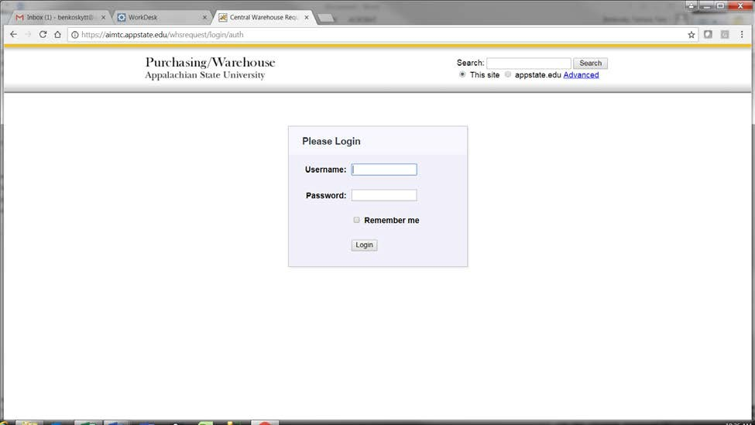
- Login with your ASU Username and Password. This will take you to the Order Form:
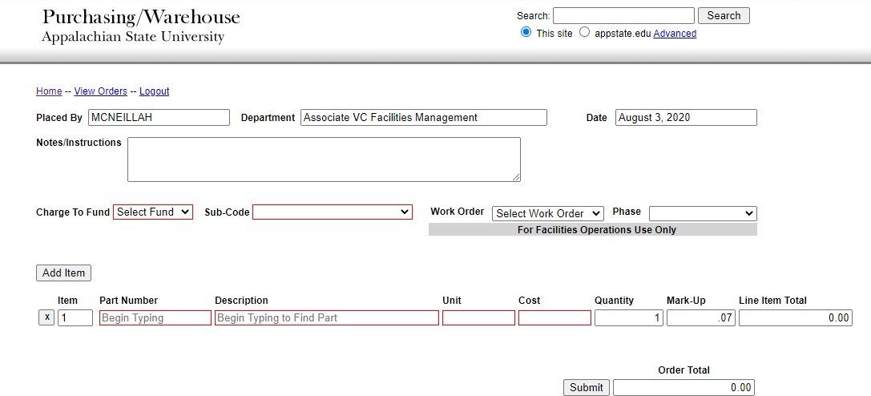

- Enter Notes/Instructions for your own reference or to the Warehouse (optional).

Facilities Operations Only (Steps 6-9):
- Select your Charge to Fund by pulling down the list under Select Fund and choosing the appropriate one for this order.
- Select the Sub-Code for this fund. One of the choices will appear automatically, but make sure to pull down the entire list in order to choose the appropriate one.
- Select the Work Order if these materials are to be charged to a Work Order by pulling down the list under Select Work Order or by starting to type the Work Order to narrow down the list.
- Select the Phase for the Work Order that you selected.
- Start entering the parts that you want to order. There are two ways you can do this:
  - Start typing the Part Number (or any portion of the Part Number). A list of items whose part number contains what you typed will appear and narrow down as you continue to type. As soon as you see the item you want, click on it and Description, Unit, and Cost will fill in automatically.
OR, if you don’t know the part number:
  - Start typing the Description (or any portion of the Description). A list of items whose description contains what you typed will appear and narrow down as you continue to type. As soon as you see the item you want, click on it and the Part, Unit, and Cost will fill in automatically.
- Enter the Quantity that you are ordering (replace the 1 if ordering more than 1). The Mark-Up, Line Item Total, and Order Total will fill in automatically. Click on Submit if this is the only item you are ordering.
- Click on Add Item to enter another part on this order. A new line will appear and you can start typing another Part Number or Description. At any time you can click on the X next to an item to delete it. Click on Submit when you have entered all of the items you are ordering at this time.
Below is an example of a completed order (before clicking on Submit:

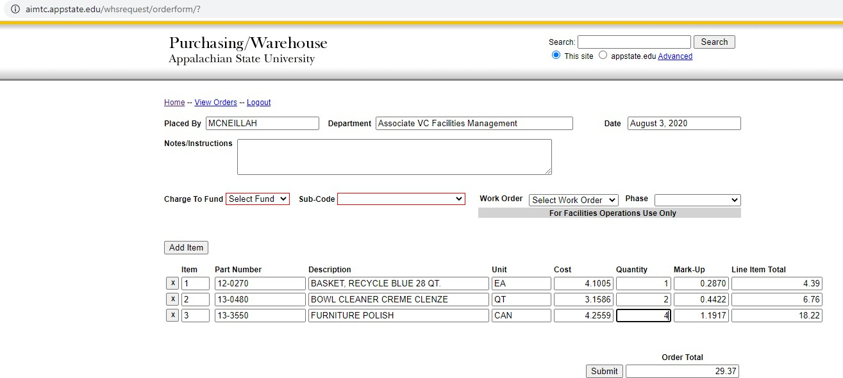

- You may now choose to Logout, View Orders, or go back to the Home page when you can enter another order. You can also view the order now from this page. You will also receive a copy of your order in a confirmation email.
If you choose to View Orders you will see a list of previous orders you have entered. You can click on any of these orders to see the details for that order.
- “X” out of this view to return to your Order History. From here you can also choose to go Home, enter a New Order, or Logout.
- After Logging out you can leave this tab open, or click the “X” on the tab to close the page.
After submitting an order you will receive an email acknowledging it with an attachment showing your “original order” – if you look this order up later after it has been closed, it will reflect what was actually sent to you.

